 | 7th Annual Tribal Nations Training Week (Virtual)

Register Now: March 14 – April 7, 2022
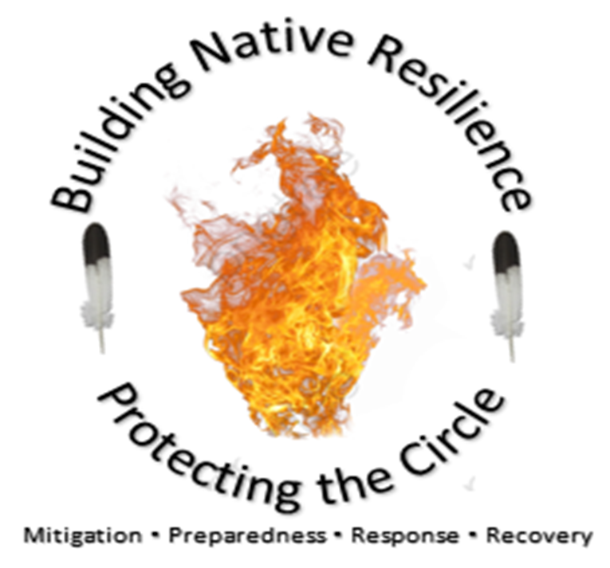
The Center for Domestic Preparedness (CDP) will host the 7th Annual Tribal Nations Training Week (Virtual) during the week of March 14 – April 7, 2022. CDP training is completely funded for state, local, tribal and territorial emergency responders. The list of classes and additional information for this training is listed below.

All personnel who work in an emergency response capacity and are affiliated with one or more Tribal Nations, Indian Health Service (IHS) and those who work directly with Tribal Nations are authorized to attend.

Training Courses

Crisis Standards of Care and Treatment Decision-Making
Date/Times: March 14, 2022 2:00 – 3:30 PM CST

Overview: Crisis Standards of Care and Treatment Decision-Making defines and explores the potential causes resulting in crisis standards of care, discusses potential situations resulting in prioritization of care, and explores legal, moral, and ethical considerations and mechanisms for making care decisions based on limited resources or capabilities. (1.5 hours)

PROMO CODE: 22NV-0614 HCV1 (PROMO Codes must be typed in as they appear and cannot be copy and pasted)

Special Needs Population Considerations During Emergency Response

Date/Times: March 15, 2022 2:00 – 3:00 PM CST

Overview: Provides an overview of the requirements, capabilities, and considerations necessary to ensure special needs population requirement are addressed during planning, preparedness, response, and recovery.(1 Hour)

PROMO CODE: 22NV-0615 HCV3 (PROMO Codes must be typed in as they appear and cannot be copy and pasted)

Hospital Incident Command System

Date/Times: March 16, 2022 2:00 – 4:00 PM CST

Overview: Hospital Incident Command System & dash; introduction to the National Incident Management System and the National Response Framework and explores the Hospital Incident Command System as a methodology for effectively applying the incident command system in a healthcare environment. The Hospital Incident Command System is discussed as it pertains to improving emergency management planning, response, and recovery capabilities for both planned and unplanned health and medical emergencies. (2 hours)

PROMO CODE: 22NV-0616HCV7 (PROMO Codes must be typed in as they appear and cannot be copy and pasted)

Contact Tracing for Transmissible Infectious Disease

Date/Times: March 17, 2022 2:00 – 3:30 PM CST

Overview: Provides an examination of the importance of contact tracing in reducing the spread of an infectious disease in a population. Addresses the procedures and considerations for effectively conducting contact tracing and explores the public health actions taken as a result of contact tracing. (1.5 Hours)

PROMO CODE: 22NV-0617 HCV11 (PROMO Codes must be typed in as they appear and cannot be copy and pasted)

Community Point of Distribution Operations (CPOD)

Date/Times: March 21, 2022 2:00 – 3:30 PM CST

Overview: The program provides a detailed discussion of point of distribution operations, to include dispensing of medical countermeasures, during a disaster or emergency. The program addresses both push and pull models and open and closed types and pull model considerations and requirements for location selection, staffing, command and control, flow, security and access control, inventory control, and demobilization. Additionally, the program examines point of distribution emergency operations planning and presents numerous tools helpful in planning and executing point of distribution and dispensing operations. (1.5 Hours)

PROMO CODE: 22NV-0618 HCV16 (PROMO Codes must be typed in as they appear and cannot be copy and pasted)

Barrier Precautions and Controls

Date/Times: March 22, 2022 2:00 – 3:45 PM CST

Overview: Addresses key infectious disease terms, standard barrier precautions and associated procedures, airborne barrier precautions and associated procedures, contact barrier precautions and associated procedures, droplet barrier precautions and associated procedures, and determination of specific barrier precautions and procedures for a designated disease. (2 Hours)

PROMO CODE: 22NV-0619 HIDV1 (PROMO Codes must be typed in as they appear and cannot be copy and pasted)

Patient Management: Receiving a Highly Infectious Disease Patient

Date/Times: March 23, 2022 2:00 – 3:45 PM CST

Overview: A discussion of infectious disease patient management processes for effectively receiving patients who are self-presenting, transported by EMS, or transferred from a community health provider. (2 Hours)

PROMO CODE: 22NV-0620 HIDV3 (PROMO Codes must be typed in as they appear and cannot be copy and pasted)

Patient Management: Management of a Highly Infectious Disease Patient in a Healthcare Facility

Date/Times: March 24, 2022 1:00 – 4:00 PM CST

Overview: A discussion of the critical processes, procedures, and considerations for safely managing a highly infectious disease patient in a healthcare facility. (3 Hours)

PROMO CODE: 22NV-0621 HIDV4 (PROMO Codes must be typed in as they appear and cannot be copy and pasted)

Emergency Communication Methods

Date/Times: March 28, 2022 2:00 – 4:30 PM CST

Overview: Addresses risk, crisis, and Crisis and Emergency Risk Communication (CERC) messages, the public's perception of risk, and key components of content and delivery of a crisis and emergency risk message. (2.5 Hours)

PROMO CODE: 22NV-0622 MPIV3 (PROMO Codes must be typed in as they appear and cannot be copy and pasted)

Media Relations and Press Conferences

Date/Times: March 29, 2022 2:00 – 3:00 PM CST

Overview: Explains the Public Information Officer (PIO)& your responsibility to effectively plan for media reaction during routine as well as emergency situations, including how to contact local, regional, and national media outlets that can be instrumental in reaching the public with emergency information. Further explains how to prepare speakers for a press conference. (1 Hour)

PROMO CODE: 22NV-0623 MPIV3 (PROMO Codes must be typed in as they appear and cannot be copy and pasted)

Communicating Effectively in an Emergency

Date/Times: March 30, 2022 2:00 – 3:30 PM CST

Overview: Addresses aspects associated with communicating with the public during emergencies. These aspects include the mapping of critical messages, debunking myths, and the needs of the media. The requirements of Public Information Officers (PIO) are also examined, along with the personnel and equipment they may need for the successful completion of their function. (1.5 Hours)

PROMO CODE: 22NV-0624 MPIV7 (PROMO Codes must be typed in as they appear and cannot be copy and pasted)

The Effective Use of Social and Traditional Media during Emergencies

Date/Times: March 31, 2022 2:00 – 3:00 PM CST

Overview: Focuses on the role of media during disaster/emergency situations and how to plan for the interaction. Additionally, there will be discussion encouraging agency communicators to evaluate their current plans for public information and ensure the plans have the appropriate balance of social and traditional media outreach. It will also encourage agencies that do not have a robust social media presence to increase their online presence to meet the needs of the communities they serve during disasters. (1 Hour)

PROMO CODE: 22NV-0625 OLS-V8 (PROMO Codes must be typed in as they appear and cannot be copy and pasted)

Critical Incident Stress Debriefing (CISD): We Need It More Than We Know,”

Date/Times: April 4, 2022 2:00 – 3:00 PM CST

Overview: Discusses how stress kills people every day, including Police Officers, Firefighters, EMS, and hospital personnel. CISD helps reduce many types of stress by participating in either defusing/debriefing sessions or both following a tragic, traumatic, and sometimes gruesome emergency scene, response, or situation. (1 Hour)

PROMO CODE: 22NV-0626 OLS-V2 (PROMO Codes must be typed in as they appear and cannot be copy and pasted)

Hospital Planning for Mass Casualty Incident Surges: Natural Disasters

Date/Times: April 5, 2022 2:00 – 3:00 PM CST

Overview: Provides guidance in planning for operational response(s) related to naturally occurring Mass Casualty Incidents (Hurricanes, Tornados, Earthquake, etc.) in terms of number and types of casualties, casualty acuity, types of injuries to anticipate staffing, logistical, and surgical needs. (1 Hour)

PROMO CODE: 22NV-0627 OLS-V4 (PROMO Codes must be typed in as they appear and cannot be copy and pasted)

Active Shooter/Assailant: Behavioral Indicators and How to Respond

Date/Times: April 6, 2022 2:00 – 3:00 PM CST

Overview: Active Shooter/Assailant: Behavioral Indicators and How to Respond will cover the fundamental elements of behavioral recognition of an active shooter such as understanding and articulating physical cues, tactical cues, and weapons cues. Additionally, directed conversation as a precursor to interview/interrogation of an active shooter will also be discussed. The Run, Hide, Fight concept for staying alive during such an event will be presented. (1 Hour)

PROMO CODE: 22NV-0628 OLS-V9 (PROMO Codes must be typed in as they appear and cannot be copy and pasted)

Emerging and Resurging Infectious Diseases

Date/Times: April 7, 2022 2:00 PM CST

Overview: Emerging and Resurging Infectious Diseases will provide a contextual understanding of the nature of emergent and resurgent diseases and a practical approach for mitigating the risks associated with infection. Discussion will include the emergence and resurgence of a variety of infectious diseases including Zika Virus, Chikungunya, Ebola, Enterovirus D68, Measles, MERS, drug-resistant shigellosis, cyclosporiasis, Highly Pathogenic Avian Influenza, COVID 19, and extensively drug resistant (XDR) TB. Also discussed will be how the awareness of the modes of contagion, the risks of infection, and the appropriate means of protection from the point of contact to presentation at a healthcare facility is critical to protect the well-being of patients and providers. (1 Hour)

PROMO CODE: 22NV-0629 OLS-V12 (PROMO Codes must be typed in as they appear and cannot be copy and pasted)

Registration:

NOTE: You must have a PROMO Code to register for one of the courses. The PROMO Code must be typed in exactly as it appears, if you cut and paste, it will not work.

Visit the CDP Website at Apply for Training to complete the online registration. Remember your FEMA SID number and Password, you will need this throughout the registration process.

Contact Information: Should you have any questions, please contact David Hall, CDP Eastern Region and Tribal Nations Training Coordinator at David.Hall@fema.dhs.gov or 866-213-9546

